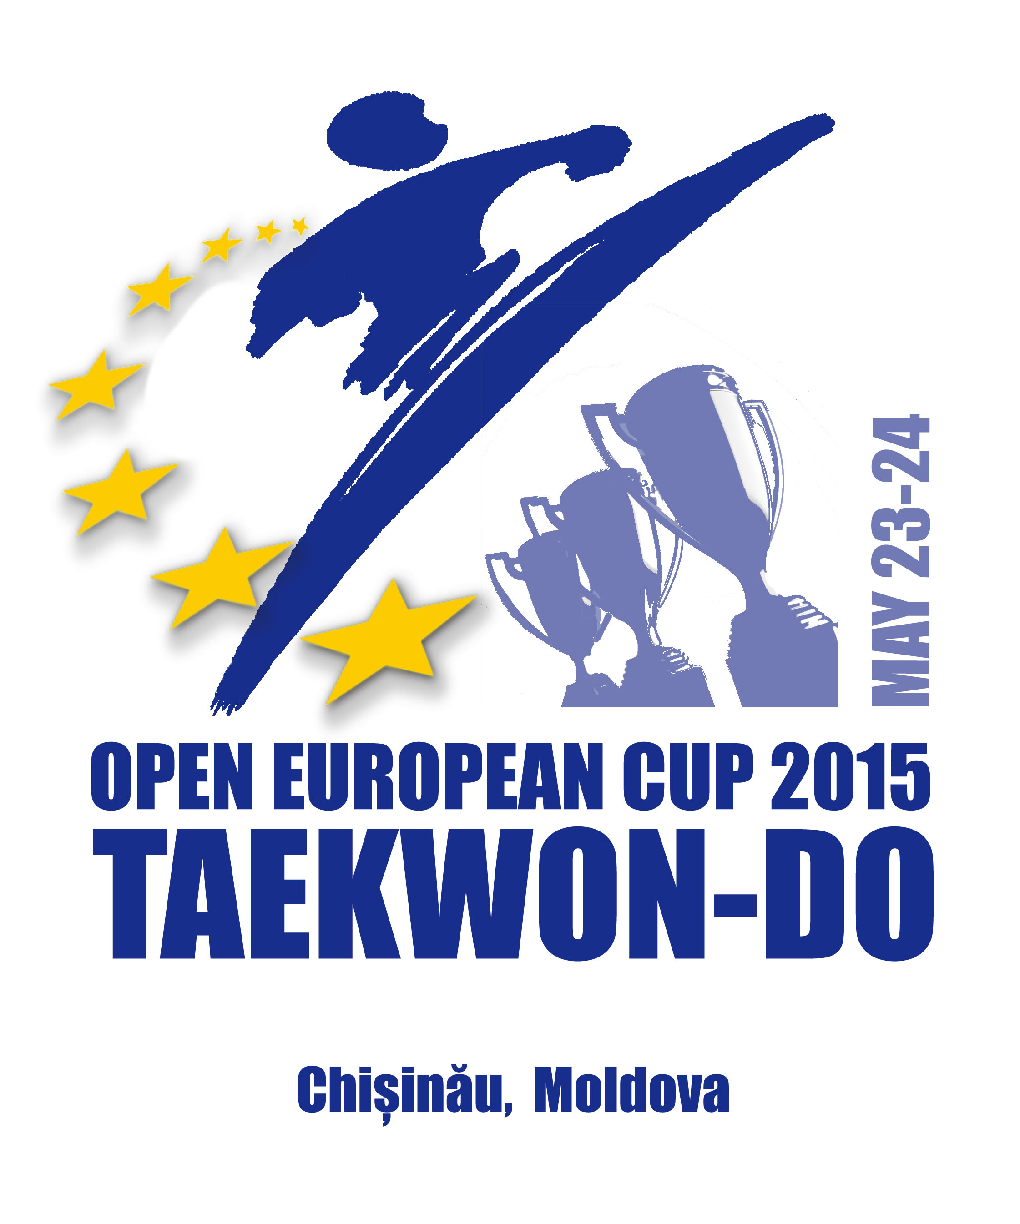
Open Taekwon-Do European Cup, 2015
May 23-24, 2015
Chisinau, Moldova

General Information

Name of the Club/Federation
Address, telephone, E-mail:
Head of delegation:
Referee: | 1. |  | 2.
 | 3. |  | 4.
Team Coach | 1. |  | 2.
 | 3. |  | 4.

Application 1
Open Taekwon-Do European Cup, 2015
May 23-24, 2015
Chisinau, Moldova

Kids, -8 years

Nr | Name, surname | Date  of birth | Sex,  F/M | Pattern | Sparring, kg
 |  |  |  | 8-6 kup | - 22 | - 26 | - 30 | - 34 | - 38 | + 38
1
2
3
4
5
6
7
8
9
10

Application 2
Open Taekwon-Do European Cup, 2015
May 23-24, 2015
Chisinau, Moldova

Kids, 9-10 years

Nr | Name, surname | Date  of birth | Sex,  F/M | Pattern |  |  | Sparring, kg
 |  |  |  | 8-7 kup | 6-5 kup | 4-1 kup | - 25 | - 29 | - 33 | - 37 | - 41 | + 41
1
2
3
4
5
6
7
8
9
10

Application 3
Open Taekwon-Do European Cup, 2015
May 23-24, 2015
Chisinau, Moldova

Kids, 11-12 years

Nr | Name, surname | Date  of birth | Sex,  F/M | Pattern |  |  |  | Sparring, kg
 |  |  |  | 8-7 kup | 6-5 kup | 4-1 kup | I dan | - 30 | - 34 | - 38 | - 42 | - 46 | + 46
1
2
3
4
5
6
7
8
9
10

Application 4
Open Taekwon-Do European Cup, 2015
May 23-24, 2015
Chisinau, Moldova

Cadets, 13-14 years

Nr | Name, surname | Date  of birth | Sex,  F/M | Pattern |  |  |  | Sparring, kg
 |  |  |  | 8-7 kup | 6-5 kup | 4-1 kup | I-II dan | - 40 | - 45 | - 50 | - 55 | -60 | +60
1
2
3
4
5
6
7
8
9
10

Application 5
Open Taekwon-Do European Cup, 2015
May 23-24, 2015
Chisinau, Moldova
Juniors, 15-17 years

Nr | Name, surname | Date  of birth | Sex,  M  /F | Pattern |  |  |  | Sparring, kg
 |  |  |  | 8-7 kup | 6-5 kup | 4-1  kup | I-II dan | - 50  /- 45 | - 56  /- 50 | - 62  /- 55 | - 68  /- 60 | - 75  /-65 | +75  /+65
1
2
3
4
5
6
7
8
9
10

Application 6
Open Taekwon-Do European Cup, 2015
May 23-24, 2015
Chisinau, Moldova

Seniors, +18 years

Nr | Name, surname | Date  of birth | Sex,  M  /F | Pattern |  |  |  |  |  | Sparring, kg
 |  |  |  | 8-7 kup | 6-5 kup | 4-1  kup | I  dan | II-III dan | IV-VI  dan | - 57  /-50 | - 63  /- 56 | - 70  /- 62 | - 78  /- 68 | -85  /-75 | +85  /+75
1
2
3
4
5
6
7
8
9
10

Application 7
Open Taekwon-Do European Cup, 2015
May 23-24, 2015
Chisinau, Moldova

Team Pattern

Juniors– male Juniors – female

Nr. | Name, surename
1
2
3
4
5

Nr. | Name, surename
1
2
3

Seniors – male Seniors – female

Nr. | Name, surename
1
2
3
4
5

Nr. | Name, surename
1
2
3

Application 8

Open Taekwon-Do European Cup, 2015
May 23-24, 2014
Chisinau, Moldova

Team Sparring

Juniors - male Juniors- female

Nr. | Name, surename
1
2
3
4
5

Nr. | Name, surename
1
2
3

Seniors - male Seniors - female

Nr. | Name, surename
1
2
3
Nr. | Name, surename
1
2
3
4
5

Hotel accommodation application form

Country, school, gym: __________________________________

Responsable:____________________________________________________________

tel/fax:_________________mobile:________________e-mail:_____________________

Please book for a total of ______ persons (include competitors, umpires, supports, others)

№ | Name, Surname | Status | Date of arrival | Date of departure

Total: double room’s _________
Please, specify an arrival time and a type of transport (number of flight or a train, the name of airline or station):

Our arrival by _________________________on ____________________
Plane, bus train, car day and date

Our departure on __________________________________
Day and date

Date: ____________________ Head of delegation: ____________________

Deadlines for following items:

Application forms must be sending before or on the deadline
of May 10th, 2015

to E-mail:

openeuropeancup@gmail.com

